PARKING
The Fillmore Philadelphia offers parking on a first come, first served basis and complimentary for all PizzaCon 24 attendees and exhibitors. Lot attendants will be staffed at each location and will only allow parking for PizzaCon attendees. There is street parking available in the surrounding area as well.

If you are driving and plan to park, we recommend that you set your GPS to 1025 N. Front St. or 98 Richmond Street (at the corner of Richmond St & Frankford Ave) in Philadelphia, PA. Parking lots open 2 hours before door time. All vehicles must vacate the lot promptly after the event ends.

1025 N. Front Street Lot
This is a gravel lot located at the corner of Front Street & Allen Street.

98 Richmond Street Lot
This is a paved lot located at the corner of Frankford Avenue & Richmond Street. This lot is shared with multiple businesses, please note to avoid parking in any marked spaces as reserved for CCTC or the Distillery.

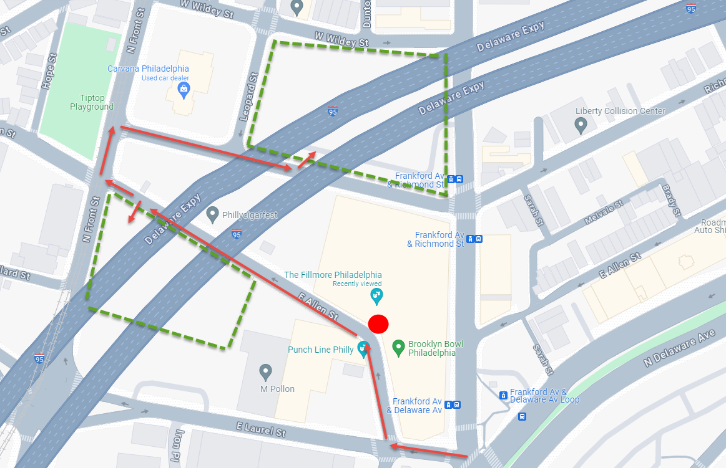

DRIVING DIRECTIONS
***All directions below will guide you to the Fillmore Philadelphia PizzaCon 2024 entrance, and subsequently to the 1025 N. Front St. parking lot.

FROM 1-95 NORTH
Take I-95 N to Callowhill St. in Philadelphia. Take exit 22 from I-95 N. Turn right onto N. 5th St. Turn Right onto Spring Garden. Turn left onto N. Front St. Turn Right onto Laurel Street. Turn Left at the stop sign onto Allen St. Drive past the Fillmore on your Right, and look for the parking signs and staff on the left before Front St.

FROM 1-95 SOUTH
Take I-95 N to exit 23 for Girard Ave. toward Lehigh Ave. Merge onto Girard Ave. Make a Left onto Frankford Avenue. Turn Right onto Laurel Street, and then an immediate Right at the stop sign onto Allen Street. Drive past the Fillmore on your Right, and look for the parking signs and staff on the left before Front St.

FROM NEW JERSEY
Take I-676 W toward the Ben Franklin Bridge/Philadelphia. Take the 5th St. exist from I-676 W. Turn right onto Spring Gard St. Turn Left onto N. Front St. Turn Right onto Laurel St. Turn Left at the stop sign onto Allen Street. Drive past the Fillmore on your Right, and look for the parking signs and staff on the left before Front St.

FROM N. DELAWARE AVE
Follow N. Delaware Ave. to Frankford Ave. Turn left onto Laural Street, and then an immediate Right at the stop sign onto Allen St. Drive past the Fillmore on your Right, and look for the parking signs and staff on the left before Front St.

